EXP 03 :
Write program demonstrates how to perform morphological analysis using the NLTK library in Python.

Aim: To write a Python program to perform morphological analysis using the NLTK library.

Algorithm:
- Import the NLTK library and WordNetLemmatizer.
- Download the required WordNet data.
- Create a list of words.
- Apply lemmatization to each word.
- Display the original words and their base forms.

Program:
!pip -q install nltk
import nltk
from nltk.stem import WordNetLemmatizer
nltk.download('wordnet', quiet=True)
nltk.download('omw-1.4', quiet=True)
lemmatizer = WordNetLemmatizer()
words = ["cars", "playing", "studies", "better"]
for word in words:
print(word, "->", lemmatizer.lemmatize(word))

OUTPUT:
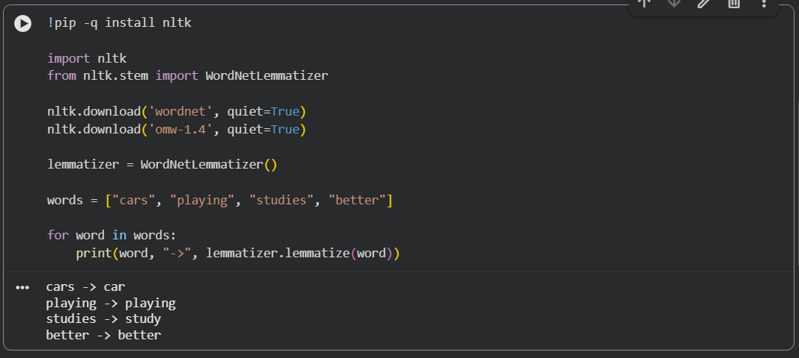

Result: Thus, morphological analysis was performed successfully using NLTK to identify the base forms of words.

